9.1 Write a program in which a string is passed by program1 to the message queue and program2 prints the same to verify it.

Code:

p1:

#include <stdio.h>
#include <stdlib.h>
#include <string.h>
#include <sys/types.h>
#include <sys/ipc.h>
#include <sys/msg.h>

struct mesg_buffer {
long mesg_type;
char mesg_text[20];
} message;

int main()
{
key_t key;
int msgid;
key = ftok("Alpha", 37);
msgid = msgget(key, 0666 | IPC_CREAT);
message.mesg_type = 1;
printf("Write Data : ");
fgets(message.mesg_text,10,stdin);
msgsnd(msgid, &message, sizeof(message), 0);
printf("Messege send is : %s \n", message.mesg_text);

return 0;
}

p2:

#include <stdio.h>
#include <stdlib.h>
#include <string.h>
#include <sys/types.h>
#include <sys/ipc.h>
#include <sys/msg.h>

struct mesg_buffer {
long mesg_type;
char mesg_text[20];
} message;

int main()
{
key_t key;
int msgid;
key = ftok("Alpha", 37);
msgid = msgget(key, 0666 | IPC_CREAT);
msgrcv(msgid, &message, sizeof(message), 1, 0);
printf("Messege Received is : %s \n",message.mesg_text);
msgctl(msgid, IPC_RMID, NULL);

return 0;
}

Output:

output1:

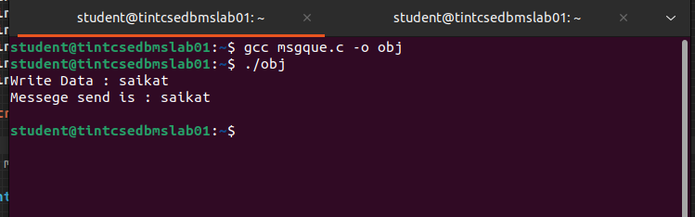

Output2:
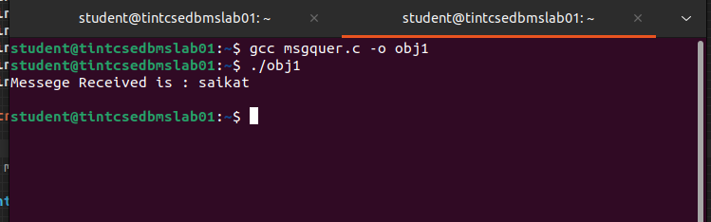

9.2 Write a program in C in which main will call a subroutine thread which will print count 10 times after that the program terminates. Try to depict the flow control from main to the subroutine thread and then back to main using statements.

Code:

#include<stdio.h>
#include<unistd.h>
#include<signal.h>
#include<pthread.h>
#include<stdlib.h>

void *funThread(void *p)
{
int count = 0;
printf("Thread begins\n");
while(1)
{
count++;
printf("\ncount=%d", count);
sleep(1);
if(count>=10)
break;
}
}
int main()
{
int a;
pthread_t th;
printf("main begins\n");
a=pthread_create(&th,NULL,funThread,NULL);
if(a != 0)
printf("Error in creation");
printf("main ends\n");
sleep(15);

return 0;
}

Output:

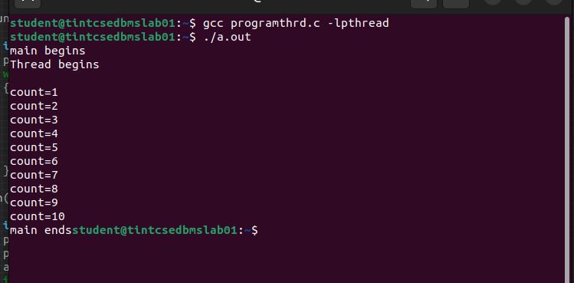

9.3 Write a program in C that will create 5 thread and each individual thread function will print the parameter/id passed from the called thread. Capture the snapshot at runtime and write your observations. Also implement suitable measures to implement sequential execution
code:

#include<stdio.h>
#include<unistd.h>
#include<signal.h>
#include<pthread.h>
#include<stdlib.h>

void *fun(void *p)
{
long tid;
tid = (long)p;
printf("Thread called is %ld\n", tid);
pthread_exit(NULL);
}
int main()
{
pthread_t th[5];
long i;
printf("main begins\n");
for(i=0;i<5;i++)
{
pthread_create(&th[i],NULL,fun,(void *)i);
pthread_join(th[i], NULL);
}
printf("main ends\n");
pthread_exit(NULL);

return 0;
}

Output:

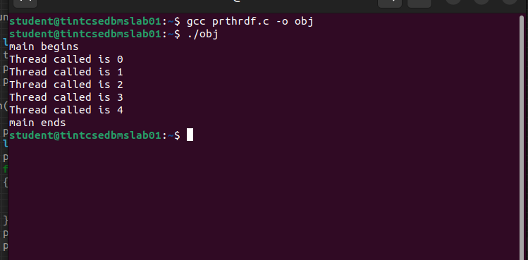

9.4 Write a program in C in which 2 threads are created and different values are called on created thread. Set the scheduling policies as Round-Robin. For each thread called, it prints and increments the value of the counter infinite number of times. Check the output and try to synchronize.
Code:

#include<stdio.h>
#include<unistd.h>
#include<signal.h>
#include<pthread.h>
#include<stdlib.h>
#include<semaphore.h>

int c=10,counter=0,c1,c2;
int tmp1;
sem_t mutex;

void *fun(void *p)
{
while(1)
{

//sem_wait(&mutex);
tmp1=rand();
c1=tmp1+c;
c2=tmp1-c;
counter++;
//sem_post(&mutex);
if(c1-c2!=2*c)
break;
printf("Thread %d in CS, c1 = %d, c2 = %d\n",*(int *)p,c1,c2);
usleep(1000);
//exit(0);

}
printf("Loop breaks in iteration %d, c1 = %d, c2=%d\n",counter,c1,c2);
}

int main()
{
pthread_t th1,th2;
int a=1,b=2;
pthread_attr_t att;
pthread_attr_init(&att);
pthread_attr_setschedpolicy(&att,SCHED_RR);
sem_init(&mutex,0,1);
pthread_create(&th1,&att,(void *)fun,&a);
pthread_create(&th2,&att,(void *)fun,&b);
pthread_join(th1,NULL);
pthread_join(th2,NULL);
sem_destroy(&mutex);

return 0;
}

Output:

